POWER BI ASSIGNMENT 2
DAX FORMULAS
- Category type – Calculated Column
Category Type =
'Order Details'[Category] & " - " & 'Order Details'[Sub-Category]

- Revenue per Order – Calculated Column
Revenue per Order =
'Order Details'[Amount] * 'Order Details'[Quantity]

- Sales Category – Calculated Column
Sales Category =
IF(
'Order Details'[Amount] >= AVERAGE('Order Details'[Amount]),
"Above Average",
"Below Average"
)

- Order Count – Measure
Order Count =
COUNTROWS('Order Details')

- Average Profit in Delhi – Measure
Average Profit in Delhi =
CALCULATE(
AVERAGE('Order Details'[Profit]),
'List of Orders'[City] = "Delhi"
)

- YTD Sales – Measure
YTD Sales =
TOTALYTD(
SUM('Order Details'[Amount]),
'List of Orders'[Order Date]
)

SCREENSHOTS
- Category Type
Created the Category Type calculated column by combining the Category and Sub-Category fields into a single column.
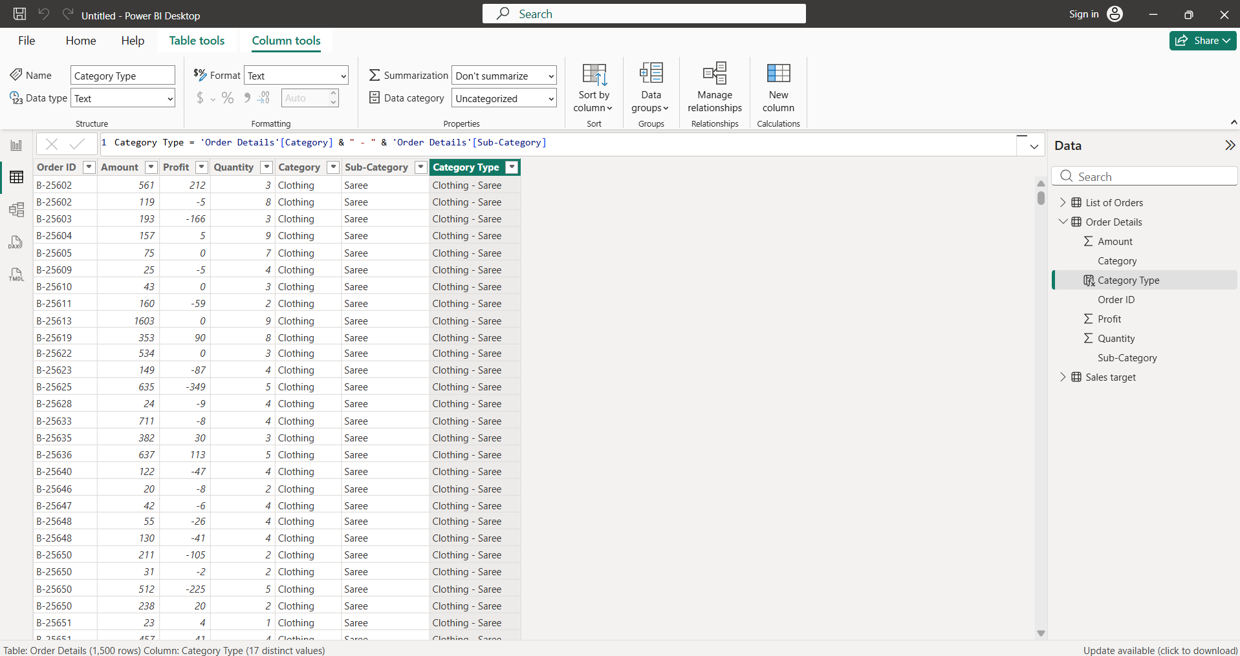
- Revenue per Order
Created the Revenue per Order calculated column by multiplying Amount by Quantity.
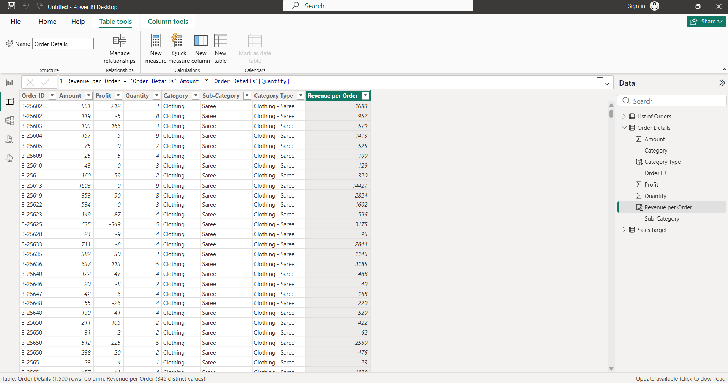
- Sales Category
Created the Sales Category calculated column to classify orders as Above Average or Below Average based on the average order amount.
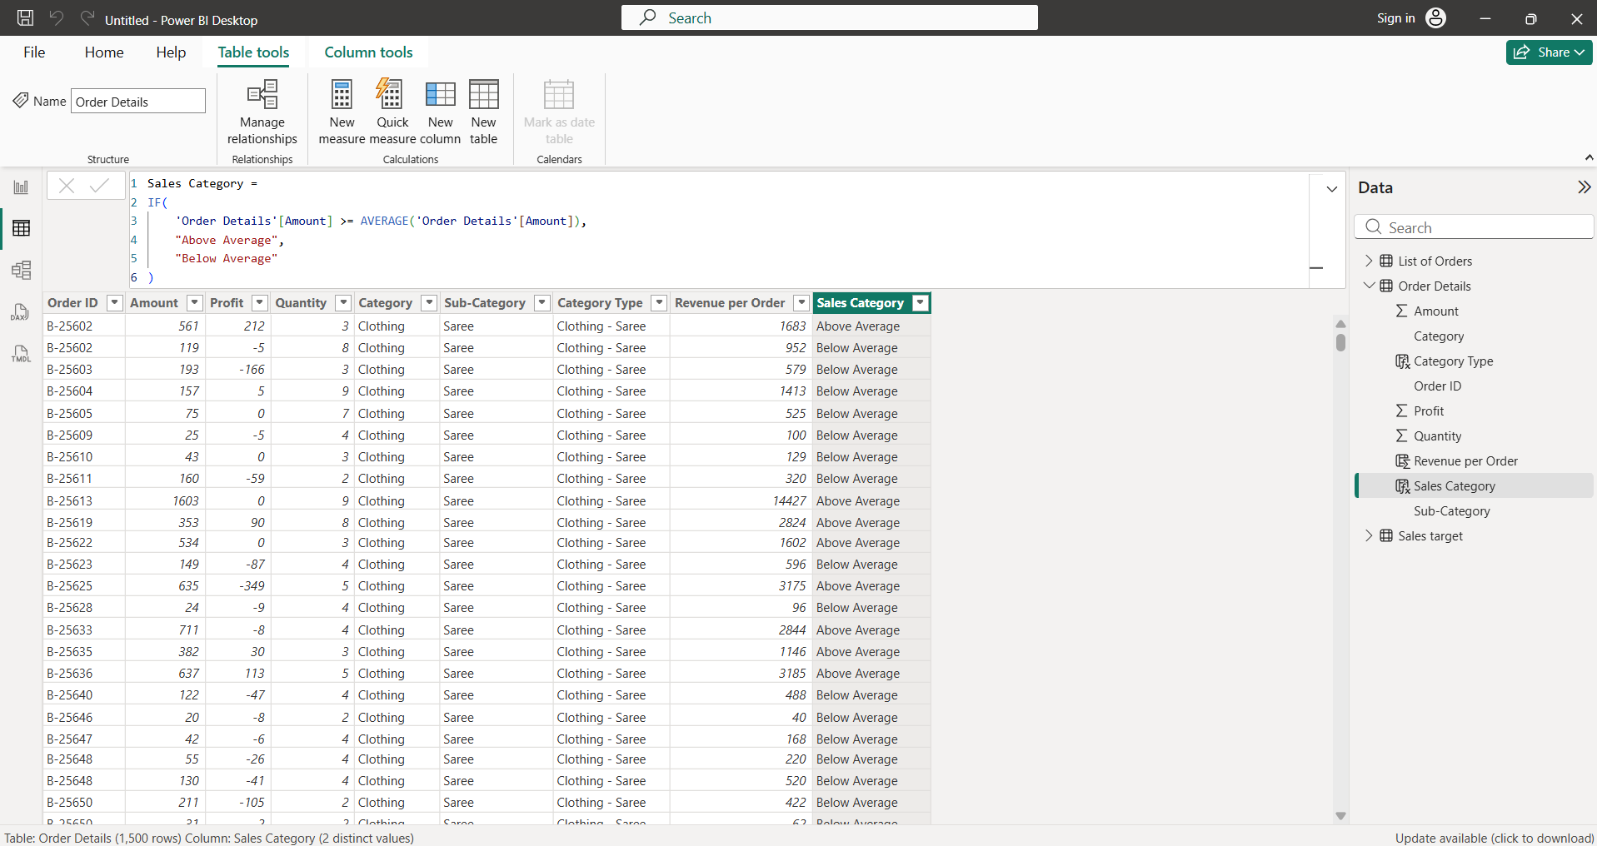
- Order Count
Created the Order Count measure using the total number of rows in the Order Details table.
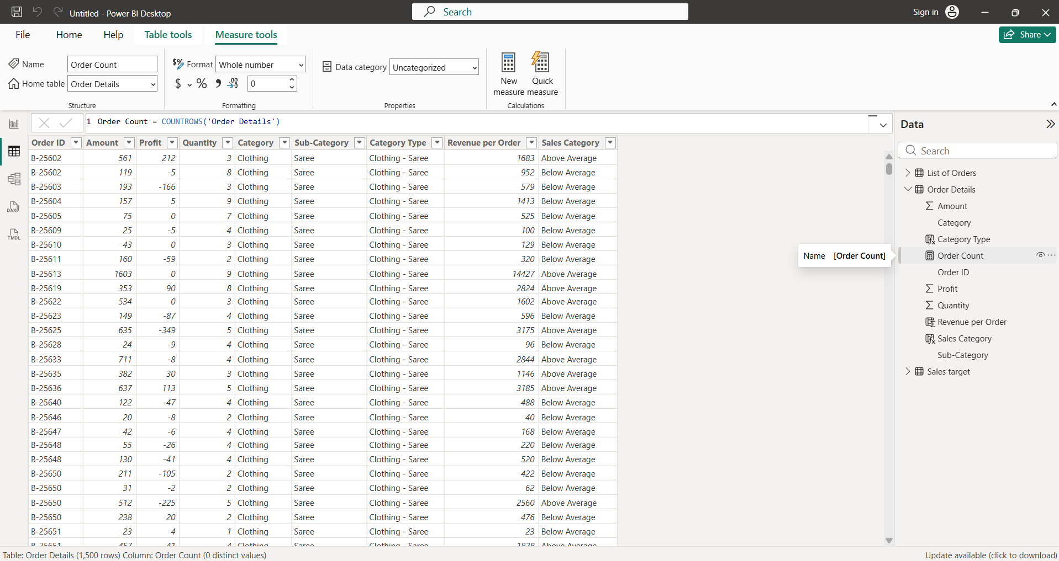
- Average Profit in Delhi
Created a measure to calculate the average profit for orders from Delhi.
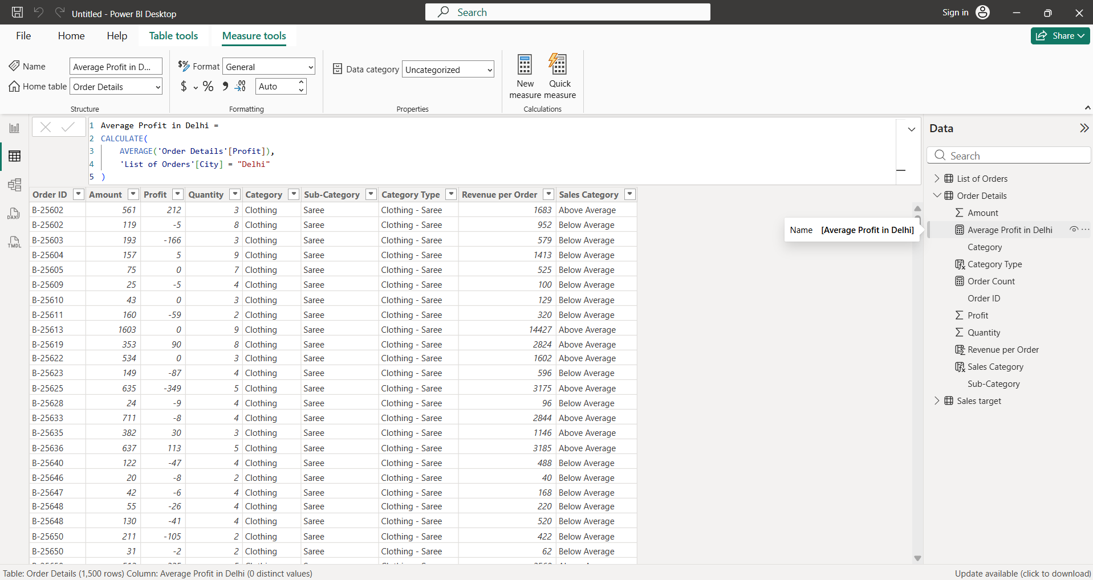
- YTD Sales
Created the YTD Sales measure to calculate cumulative sales from the beginning of the year up to the selected date.
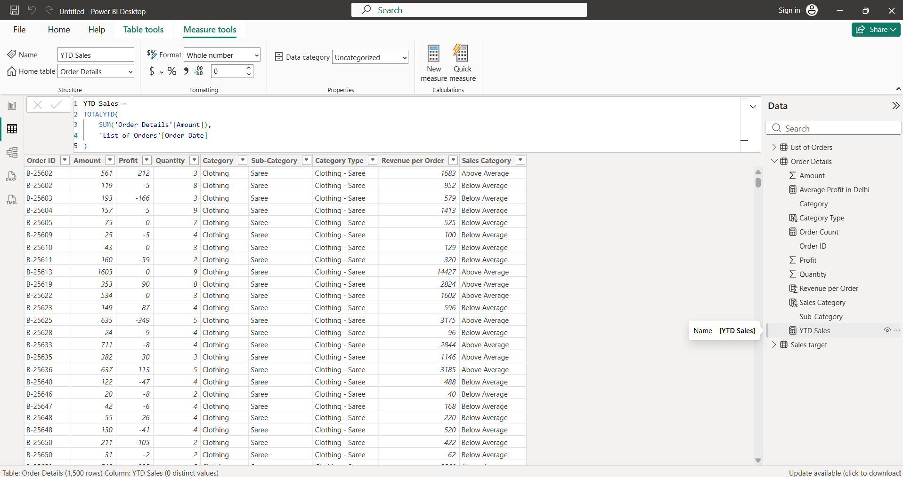
Data Visualizations
- Sales Target Achievement by Category
Created a clustered column chart comparing actual sales amount with sales targets across categories.
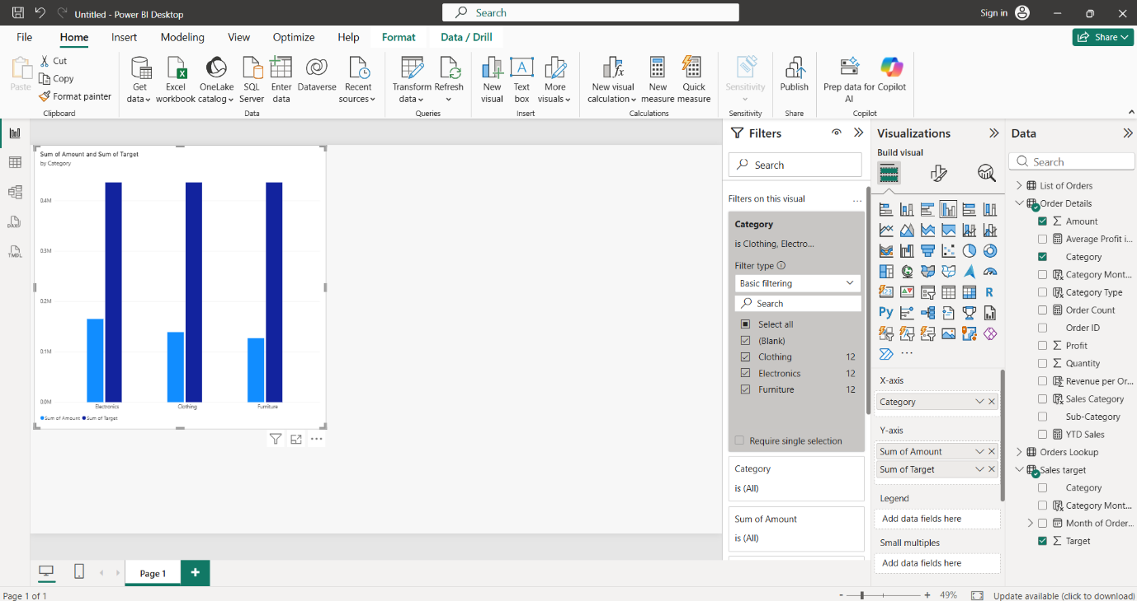
- Max Profit Margin by Sub-Category
Created a donut chart showing the maximum profit margin for each sub-category.
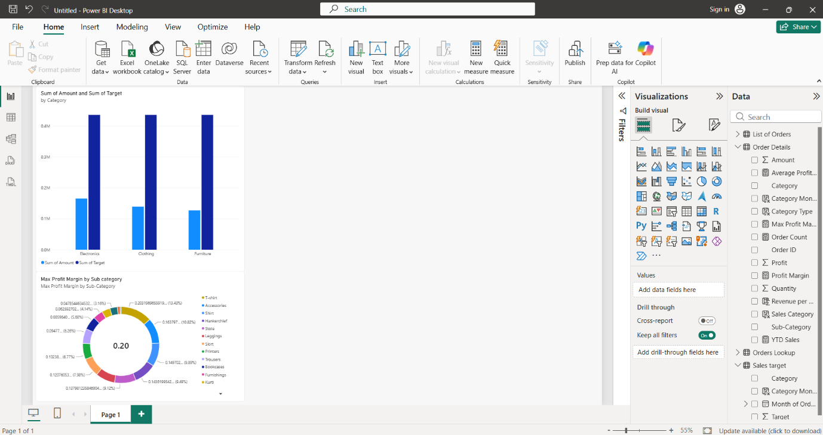
- Monthly Sales Trend
Created a line chart to visualize the trend in sales amount across months.
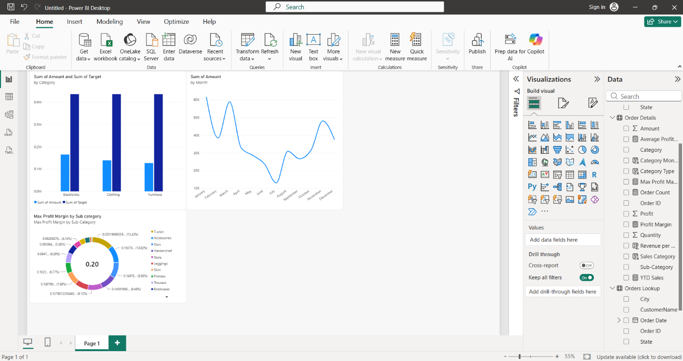
- Profit vs Quantity by Sub-Category
Created a scatter chart to analyze the relationship between quantity and profit across sub-categories.
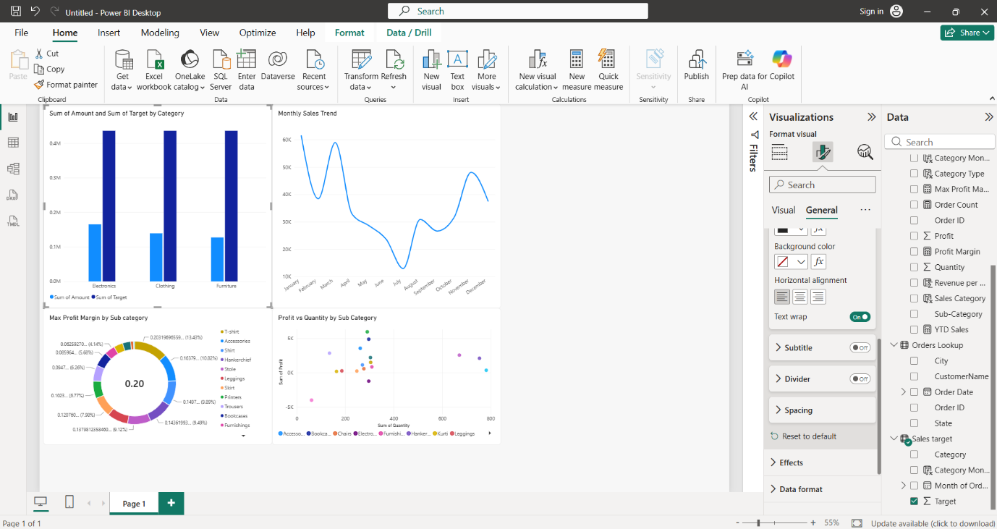
- Total Sales Amount and Target
Created card visuals displaying the total sales amount and total sales target.
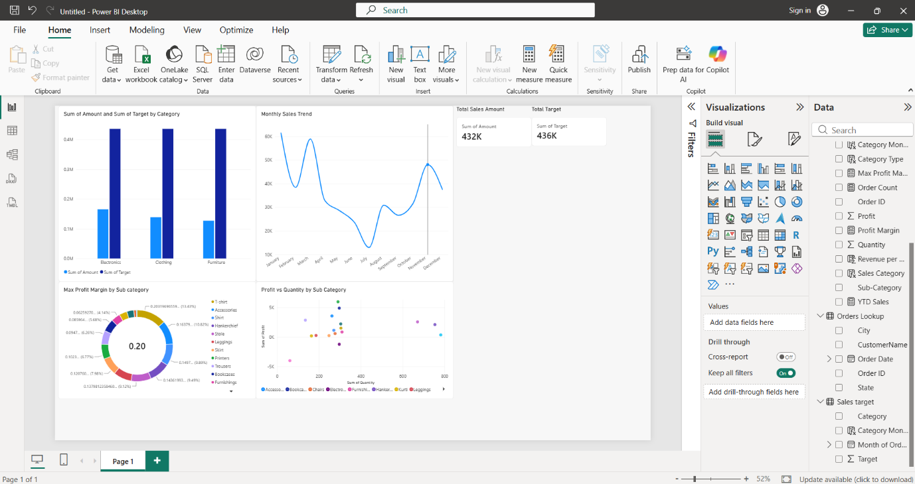
- Minimum Target by Category
Created a multi-row card showing the minimum sales target for each category.
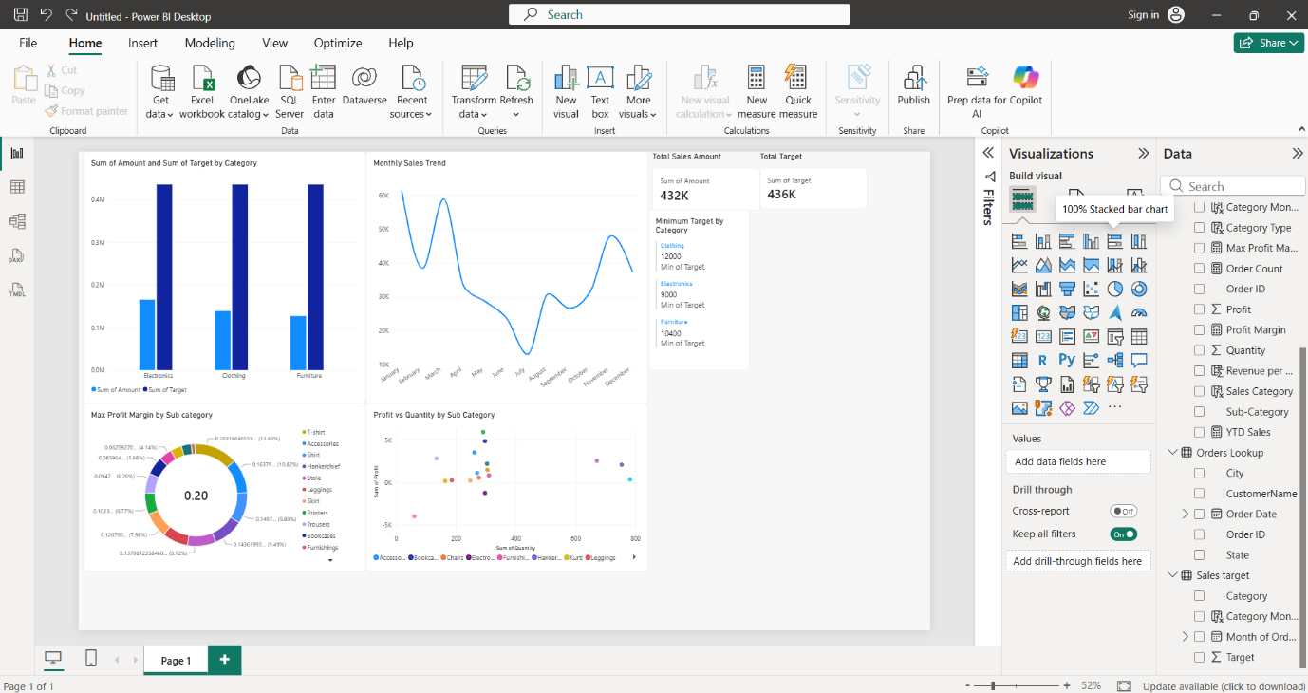
- Sales Performance Matrix
Created a matrix comparing actual sales and corresponding targets across categories and months.
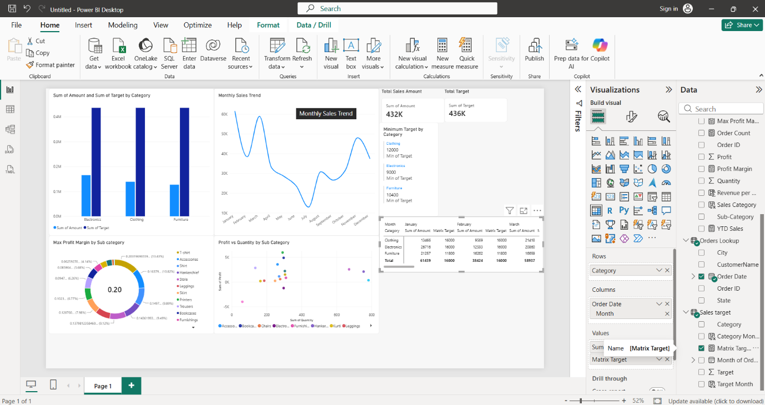
- Geographic Sales Analysis
Created a map visualization showing sales distribution by city, with the size of the bubbles representing sales amount.
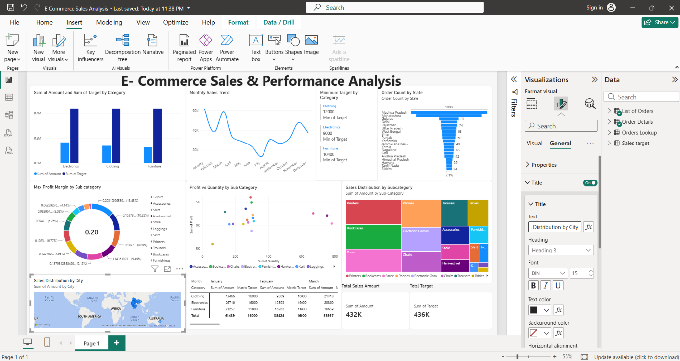
- Sales Distribution by Sub-Category
Created a treemap to visualize the distribution of sales amount across different sub-categories.
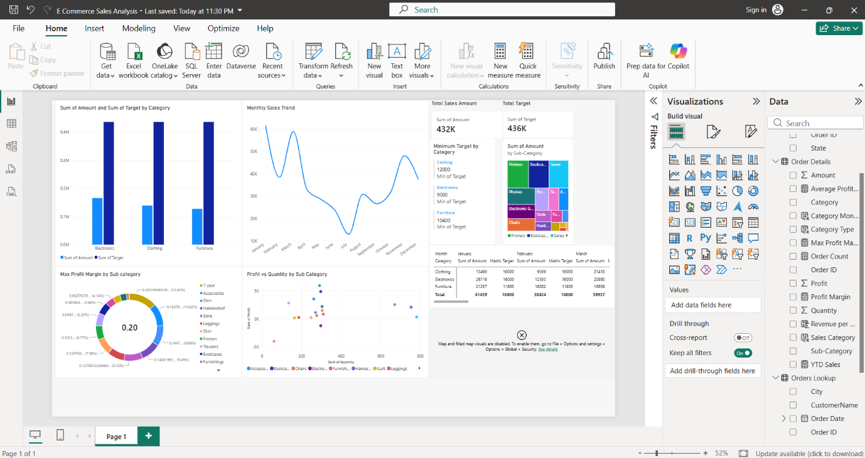
- Order Count by State
Created a funnel chart displaying the order count across different states.
